Potential reviewers:
Christine Stawitz, Steve Cadrin, Peter Kuriyama

Intended Journal:
Fisheries Research

Title: Spatial variation in growth and lack of fishery-dependent age data lead to model misspecification in age-structured stock assessment models, as applied to Gulf of Alaska rex sole

Title: The importance of accounting for spatial growth patterns in statistical catch-at-age models when sources of age data are missing, using Gulf of Alaska rex sole (Glyptocephalus zachirus) as an example

Title: How missing fishery age data masks assessment model mis-specification for stocks with spatial growth patterns, using Gulf of Alaska rex sole (Glyptocephalus zachirus) as an example

Title: Missing fishery age data, a spatial growth pattern, and spatially-varying fishing intensity: a recipe for major bias in stock assessment models
Missing fishery age data and spatially structured growth and fishing causes stock assessment model bias

Authors: Carey R. McGilliard¹, Meaghan Bryan?, Paul Spencer?
¹Alaska Fisheries Science Center, National Marine Fisheries Service, National Oceanic and Atmospheric Administration, 7600 Sand Point Way NE., Seattle, WA 98115-6349, corresponding author: carey.mcgilliard@noaa.gov

Highlights
- Many statistical catch-at-age assessment models lack fishery age data; we show that model misspecification can be masked by missing fishery ages
- Historically, Gulf of Alaska rex sole was modeled as a single-area stock assessment with missing fishery age data that showed reasonable fits to data sources and very high fishery reference points (F_{40%} of 1.79)
- Adding fishery age data to the one-area GOA rex sole model led to poor fits to fishery length data and substantially lower fishery reference points (F_{40%} of 0.22)
- Data exploration showed two distinct growth patterns by area for GOA rex sole
- Using a two-area model configuration with growth estimated separately by area led to substantially lower fishery reference points than for the one-area model with missing fishery age data, regardless of inclusion of fishery age data in the two-area model configuration.

Abstract
Conventional stock assessment models are one-area, assuming a uniform growth pattern across space and time. For many species, survey age data may be available for use in integrated statistical catch-at-age models, but fishery ages may not have been collected. This is the case for many Gulf of Alaska (GOA) groundfish species. Spatial growth patterns may appear as high variability in length-at-age when viewing and analyzing data in aggregate over space. Here, using GOA rex sole as an example, we show that ignoring a spatial difference in the maximum length of fish in the absence of fishery age data can lead to highly mis-specified assessment models with seemingly reasonable model fits. Key factors that contribute to mis-specification are (1) differences in fishing mortality rates across areas that correspond with distinct growth morphs such that growth estimates are not representative of the size-at-age of the catches, and (2) high variability around growth estimates, which allows the model excess flexibility in estimation of selectivity curves. We show that the addition of newly-available fishery age data led to poor, biased fits to age- and length-composition data, which were greatly improved by implementing a two-area model, estimating growth separately for each area. For the example of GOA rex sole, an assumption of sedentary adults and global pooling of larvae with a constant, estimated proportion of recruitment allocated to each area appeared to be reasonable assumptions. The GOA rex sole example is the first known 2-area growth-morph model to be used as a “production assessment” for specifying Allowable Biological Catch (ABC). While a one-area GOA rex sole model estimated F_{40%} = 1.47 (due to recruitment to the fishery estimated as occurring after maturity), the two-area model estimated an F_{40%} of 0.6. In addition, a two-area model excluding fits to fishery age data shows similar estimates of biomass and fishery reference points as for the same model including fits to fishery age data, suggesting that an area-specific or time-varying approach to estimating growth may be worthwhile for reducing mis-specification for other species exhibiting spatial growth patterns and where fishery age data are unavailable.

Introduction
Although single-area age-structured statistical catch-at-age models are commonly used to assess fish stocks around the world (Maunder and Punt, 2013), many approaches to spatial stock assessment and accounting for spatial patterns in population and fishing processes have been developed (Punt, 2019). Simulation studies show that while spatial assessment approaches often generate more accurate estimates of population abundance. Several cases exist where ignoring spatial aspects of population processes led to major failures in fisheries management (Cadrin, 2020). However, splitting data sources into multiple spatially-explicit, but smaller data sets can lead to high imprecision due to sparse data in some areas (Punt et al. 2019). In addition, spatial population models are more complex as they require assumptions and estimation of parameters defining juvenile settlement and adult movement (Goethel et al., 2011; McGilliard and Hilborn, 2008).
Many stocks exhibit spatial variation in growth (Gertseva et al., 2017; Punt et al., 2015).
Simulation analyses show that ignoring spatial and temporal growth patterns and variability in growth estimates within assessments can to lead to biased and imprecise assessment results, particularly when fishing mortality differs across the range of the stock (Correa et al., 2021). Stawitz et al. (2019) simulated a population with time-varying growth regimes and yearly deviations in growth parameters and found that ignoring time-varying growth in an assessment led to bias in estimates of depletion and spawning biomass at maximum sustainable yield, which were largely resolved or reduced by estimating time-varying growth, with the exception of some data poor scenarios. Kuriyama et al. (2016) found that using empirical weight-at-age data by year within assessment models was an effective alternative to including length and age data and estimating of growth parameters within the model under time-varying growth. While simulation studies are a valuable way to explore the impact of model misspecification within a controlled environment, in practice, conducting an assessment for a particular stock is more complex. Stock assessments grapple with data limitations and idiosyncrasies, as well as other complexities, such as additional time and spatially-varying processes, fleet behavior, and mismatches between the scale of population processes and the scale of management. In practice, the truth is unknown so we rely on a suite of diagnostic plots and calculations, as well as contextual knowledge of the system to inform whether a model is adequately capturing stock dynamics and should used to determine management quantities.
One typical data idiosyncrasy is missing fishery age data due to lack of collections or limited ageing effort. Therefore, many stock assessments utilize only survey length and age data, which are fit outside the stock assessment model using estimates from von-Bertalanffy growth curves, along with estimates of variability in growth (C. McGilliard et al., 2015; Stockhausen et al., 2011), or are fit inside of the model using a “conditional age-at-length” approach that uses a multinomial objective function to fit the model to age data within each length bins (Methot and Wetzel, 2013). In a single-area model, typically age-length data for the entire range of the survey are included in the analysis.
Gulf of Alaska rex sole is one such stock, where historically, a single-area statistical catch-at-age model was fit to survey age-length data, survey length composition data, and a survey biomass index, as well as catches; fishery age data were unavailable. These single-area statistical catch-at-age models led to biomass reference points and fits to each data source that appeared to be reasonable, but with very large values for fishery reference points, with F_{40%} equal to approximately 1.79. Large values for fishery reference points occurred because the model estimated a fishery selectivity curve such that only mature fish were caught. Using GOA rex sole as an example, we explore differences in length-at-age in survey data for GOA rex sole between the Eastern and Western-Central GOA. We explore the importance of including fishery age data for estimating fishery reference points and making catch limit recommendations. We ask whether accounting for differences in observed growth patterns across the GOA through a two-area statistical catch-at-age model can improve model fits to the data. We also explore whether a two-area model configuration estimating different growth patterns in each area, but without inclusion of fishery age data would lead to similar fishery reference points and catch limit recommendations as for one- and two-area models including fishery age data. Finally, we compare fishery reference points and catch limit recommendations across all four models.

Methods

General summary of GOA rex sole population and fishery
Rex sole (Glyptocephalus zachirus) occurs from southern California to the Bering Sea, ranging from less than 100m to about 800 meters in depth (Mecklenburg et al., 2002). They are most abundant at depths between 100 and 200m and are found throughout the Gulf of Alaska (GOA), with the highest biomass found in the Central GOA. Abookire (2006) found marked differences in growth rates and female size at maturity between stocks in the GOA and off the coast of Oregon. Rex sole are batch spawners with a spawning season spanning at least 8 months, from October to May. Larvae are thought to spend up to 9 months in a pelagic stage in the northern GOA before settling out to the bottom as 5 cm juveniles (Abookire and Bailey, 2007; Pearcy et al., 1977). Rex sole are one of several GOA flatfish species with larvae that exhibit cross-shelf transport, moving to several nearshore nursery areas where they remain as juveniles (Bailey et al. 2008, Abookire and Bailey 2006). Several flatfish species in the Gulf of Alaska, including rex sole, Dover sole, Pacific halibut, and arrowtooth flounder have shown synchrony in recruitment patterns over time that have been linked to an environmental indicator related to sea surface height (Stachura et al. 2014). They live to be about 30 years old; there are several observations of 30-40 year old rex sole in the GOA and one 49 year old.
Little is known on the stock structure of GOA rex sole. However, otoliths exhibit two distinct growth patterns (pers. Comm. D. Anderl 2015) and data show that length at older ages in the Eastern GOA is smaller than those for the Western and Central areas (Figure 1). Rex sole in the Gulf of Alaska are caught by bottom trawl in a multi-species groundfish fishery. Typically, approximately 7 months of fishing occur between January and November and the greatest proportion of catches typically occur in the second quarter of the year. Catches of rex sole occur primarily in the Western and Central management area in the Gulf, with the greatest proportion of catch in the Central region.

Data sources
The data sources used in the study are listed in Table 1. The catch history of GOA rex sole, used in each model, and is shown in Figure S1; the fishery operates only by trawling in the Western-Central GOA. A partial coverage fishery observer program collected biological samples of rex sole in the GOA, which were included in this study. We used fishery observer collected raw proportion at each length as length composition data within each assessment configuration, as some historical length samples were collected at the port with no accompanying haul information to use for further standardization. In addition, fishery observers randomly sample otoliths that were subsequently aged for age composition inputs to each stock assessment model. All fishery age samples used break-and-burn methods and were aged in 2015-2017.
This assessment used estimates of total biomass for rex sole in the Gulf of Alaska from triennial (1984-1999) and biennial (2001-2021) groundfish surveys conducted by the AFSC’s Resource Assessment and Conservation Engineering (RACE) division to provide an index of population biomass. Survey biomass has fluctuated on decadal time scales (Figure S2). Consistently over time, survey biomass has been greatest in the Central GOA and smallest in the Western GOA, but occurs in all three regions (Central, Eastern, and Western GOA).
Estimates of GOA-wide and area-specific (Western-Central and Eastern GOA) proportions-at-length (length composition data) were included as inputs to each model configuration. The raw number of individuals at each age by length group (conditional age-at-length, or CAAL data) from each RACE GOA groundfish survey were included as inputs to each model. Survey age data were available for all survey years except for 2021. The age data for 1990 were excluded from the model because the underlying ages may be biased due to the age reading technique (surface age reading) used to process the otoliths.

Stock Assessment Modeling
All of the stock assessment models used were split sex, age-structured statistical catch-at-age model implemented in Stock Synthesis version 3.3 (SS) using a maximum likelihood approach. SS equations can be found in Methot and Wetzel (2013) and further technical documentation is outlined in Methot (2009). Age classes included in the model run from age 0 to 20. The oldest age class in the model, age 20, serves as a plus group. Age at recruitment was set at 3 for the purpose of projections and calculation of management quantities, as few rex sole are observed before age 3. Survey catchability was estimated with a prior based on herding experiments in the current assessment. All models estimated a single survey catchability parameter (q) with a normal prior with a mean of 1.2 and standard deviation of 0.175 (based on herding studies for the stock (Somerton et al., 2007) and one unfished recruitment parameter (R₀), shared across the GOA, along with one recruitment deviation for each year, shared across the GOA. Recruitment deviations were estimated for an early period from 1965-1981 and a current period from 1982-2019 with a σ_{R} = 0.6 and were set to mean recruitment for 2020-2021 (little information exists on 0-1 year old GOA rex sole and recruitment cannot be estimated reliably for these years). The steepness parameter of the stock-recruitment curve was set equal to 1 in all models, meaning that we assumed no stock-recruitment relationship, as is the case for many stock assessments in GOA.
Age-based double-normal functions without a descending limb (instead of a logistic function) were used to model fishery and survey selectivity for all model runs. The double-normal formulation was used because the SS modeling framework does not currently include the option of estimating sex-specific, age-based logistic selectivity where both male and female selectivity maintain a logistic shape.
We modeled growth according to the von-Bertlanffy growth curve using a conditional age-at-length approach (CAAL), where the distribution of ages within each length bin are assumed to follow a multinomial distribution as components of the objective function for each integrated model. The models were fit to raw survey age data collected within each length bin, and to aggregated survey length composition data (assuming a multinomial distribution over length bins). We estimated von-Bertalanffy k, L_{max}, and L_{min}, and the CV of the youngest and oldest fish separately for females and males. Natural mortality was set equal to M = 0.2 yr⁻¹ for all models and areas. In addition, we assumed a fixed allometric weight-length relationship with sex-specific parameters ($w_{l,s}=α_{s}L_{s}^{β_{s}}$) with α = 1.35E-06 and 2.18E-06 and β = 3.44963 and 3.30571 for females and males, respectively, and a fixed age-based logistic maturity-at-age relationship with an age at 50%-maturity estimated to be 5.7 years and a slope equal to -1.113 (Figure SXX), both estimated outside of the models. Survey data showed a consistent weight-length relationship across time and the GOA. Maturity-at-age data were collected at a single snapshot in time from a small region in the GOA (Abookire, 2006).
We developed four model and data configuration scenarios: (1) a single-area model without fishery age data, (2) a single-area model with fishery age data, (3) a two-area model with the Western-Central GOA as one area and the Eastern GOA as the other area with fishery age data, and (4) a two-area model with the Western-Central GOA as one area and the Eastern GOA as the other area without fishery age data. The input data and configuration files corresponding to all assessment models can be found in our Github repository: https://github.com/careymcg/AreaGrowthRex/tree/main/ss.
We weighted data sources relative to one another using methods described in Francis (2011), Equation TA1.8. Input sample sizes for length composition data was set equal to the number of hauls and input sample sizes for conditional age-at-length data was set equal to sample sizes.

One-area model configurations
For the one-area model configurations, separate growth curves were estimated for females and males for the whole GOA rex sole stock (Western-Central and Eastern GOA combined), as well as a single survey selectivity curve (aggregated over sex and applied across the Western-Central and Eastern GOA), and sex-specific fishery selectivity curves Male survey selectivity was nearly identical to female survey selectivity in preliminary model runs for one- and two-area models and therefore male and female survey selectivity was set to be equal.

Two-area model configurations
The two-area model configurations represented the Eastern GOA and Western-Central GOA with separate growth curves estimated based on survey data from each area. We split the survey data by region with one area representing the Eastern GOA and the other representing the Western-Central GOA. Survey biomass estimates, length composition data, and conditional age-at-length data were input separately for these two regions. We used a single survey catchability parameter for both areas. A non-time-varying parameter was estimated to specify the proportion of recruits that settle in the Eastern GOA. Therefore, we assumed that the Eastern and Western-Central GOA have a similar recruitment pattern across years. We assumed that all fishing occurred in the Western-Central GOA (as very few catches have originated in the Eastern GOA; most of the Eastern GOA is closed to trawling). Survey selectivity parameters and growth parameters were sex-specific and estimated for each of the two regions separately.

Comparison of Models
We used several diagnostics to compare fits to data for each model configuration, including (1) fits to length composition data aggregated over time, (2) fits to growth data aggregated over time. In addition, we calculate SPR-based fishery reference points for each model configuration.

Results

Patterns in age-length observations
Raw age-length observations from the GOA bottom trawl survey show that fish in the Western-Central GOA grow larger at older ages (40-65 cm and 35-60 cm for females and males, respectively) than do fish in the Eastern GOA that achieve a maximum size of 35-45 cm and 30-40 cm for females and males, respectively (Figure 1). Further exploration of age-length observations show similar growth patterns in the Western and Central GOA. In addition, age-length patterns appear to be similar by depth and year (Figure S.1-S.5). Fishery age-length observations originate only in the Western and Central GOA and appear consistent with survey observations from the Western-Central GOA, and by season (see Supplementary Materials).

Single-area assessment models with and without fishery age data
One-area model fits to the GOA bottom trawl survey biomass data are similar with and without fishery age data included (Figure 2). In addition, fits to survey length composition data and survey age-length data aggregated over time are identical or nearly identical between the one area models with and without fishery age data (Figure 3 and Figure 5, left two columns). However, fits to fishery length composition data aggregated over time appear to be reasonable for the one area model without fishery age data, but are substantially skewed to the left relative to the data for the one-area model with fishery age data (Figure 3, top row). While the peak proportion of length composition data occurs at 45cm for females and 35 cm for males, the peak of the fits to length composition data for the one-area model with fishery ages occurs at 40 cm for females and 32 cm for males (Figure 3).

Two-area assessment models with and without fishery age data
The two-area model estimates distinct von-Bertalanffy growth curves by area and sex for the Western-Central GOA and the Eastern GOA (Figure 5, right two columns). The parameter Lmax is xx for the Western Central GOA and yy for the Eastern GOA for females and males, respectively (Figure 5 and Figure Sxx). The 90% asymptotic uncertainty intervals corresponding to the estimated von-Bertalanffy growth curves for the Eastern GOA are entirely below the mean von-Bertalanffy growth curve estimate for the Western-Central GOA for both females and males (Figure 5).
Fits to fishery length composition data aggregated over time for the two-area models are both much less skewed than for the one-area model with fishery age data (Figure 6). The two-area model with fishery age data estimates a broader distribution across lengths with some overestimation of the proportion at lengths of 20-35 cm for females and 25-30 cm for males. However, the peak estimated proportion-at-length occurs at approximately 45cm for females and 38-40 cm for males for two-area models with and without fishery age data included (Figure 6). Two-area model fits to fishery age data aggregated over time are very similar to those estimated by the one-area model with fishery ages included (Figure 7).
Figure Sxx shows that the fits to GOA bottom trawl survey biomass indices for the two-area models with and without fishery age data are similar.

Comparing management quantities and population dynamics from each model
The estimate of F_{40%} and corresponding projected catches for the following year were extremely high for the one-area model without fishery ages incorporated (F40% = 1.79; Table 2). This high value occurs because the estimated fishery selectivity-at-age indicates that nearly all female fish are mature when they start to be caught by the fishery; fishery selectivity is estimated to be zero until age 7 (Figure 9, top row). Estimates of fishery selectivity-at-age are sensitive to the inclusion of fishery age data (one- and two-area models with fishery ages included estimate similar fishery selectivity curves) to the area-specific model configuration (Figure 9). The two-area model without fishery ages estimates selectivity to the fishery to occur later than in the models with fishery ages included and earlier than in the one-area model without fishery ages. In turn the estimates of F40% for both models including fishery ages is almost identical (0.22 for the one-area model and 0.23 for the two-area model), while the estimate of F40% for the two-area model without fishery ages is slightly higher at 0.36 in the Western-Central region where the fishery occurs. Projected estimates of catches in the western-central region corresponding to F40% range between 12,279 and 18,827 for models where either fishery ages are included and/or a two-area model configuration is used to account for the spatial growth pattern in the data. In contrast, projected catches corresponding to F40% for the one-area model without fishery ages is 1.7-2.6x the magnitude of projected catches for the other three models.
Estimated 2022 spawning biomass ranged from approximately 40,457 t to 57,845 t across the four model configurations. Spawning biomass estimates for the model configurations with fishery ages are similar to each other, and the model configurations without fishery ages are similar to each other (Figure 8). Recruitment estimates show similar patterns across models, with a large year class in 2015 captured by all four model configurations. The two-area model without fishery ages estimated the largest 2015 recruitment and the one-area model with fishery ages estimated the smallest 2015 year class of the four models (Figure 8). Trends over time in fishing intensity (shown as one minus the spawning potential ratio) are similar across models with the highest estimated fishing intensity estimated by the one-area model configuration and the lowest fishing intensity over time estimated by the two model configurations without fishery ages (Figure 8). These time-series trends indicate that fishery age data still influence model results, despite accounting for spatial growth patterns with a two-area model configuration.

Discussion
We show that a mis-specified statistical catch-at-age model with apparent extreme bias in fishery reference points can exhibit reasonable fits to all data sources. In the Gulf of Alaska rex sole example, the lack of fishery age data masked the model mis-specification in a spatial growth pattern because the fishery only harvests fish from a single area and growth pattern. Without the fishery age data and with two growth patterns represented in survey age-length data, the one-area model estimates a single von-Bertalanffy growth curve based on highly variable age-length observations and with large estimates of variability in length-at-age (Figure 5). This variability in length-at-age, in concert with fishery length composition data allows the model substantial flexibility in estimating fishery selectivity parameters (which are not ground-truthed by any fishery ages). The resulting fishery reference points in the GOA rex sole example are extreme because the model estimates indicate that fishery selectivity occurs quite a bit later than maturity-at-age for females (Figure 9). For GOA rex sole, an obvious next step is to investigate maturity-at-age and account for uncertainty in maturity-at-age in the stock assessment. However, more generally, it is a common data scenario in stock assessment, even in data rich regions (like Alaska), to have access to survey ages, as well as fishery lengths, but no fishery age data, as collection and ageing of otoliths is resource intensive and it requires extra effort to collect a meaningful number of fishery otoliths from underutilized and non-target stocks. For example, many flatfish stocks in Alaska (not just GOA rex sole) exhibit spatial and/or temporal patterns in growth, are lacking fishery age data, and have been analyzed with one-area statistical catch-at-age models with time-invariant growth, estimated within or outside of the model (e.g. Dover sole, GOA NRS). It may be worthwhile to investigate the role of model misspecification in the determination of catch recommendations for these stocks. This work has already begun for … (e.g. Bryan et al. use a two-area model to analyze GOA Northern rock sole).
In the GOA rex sole example, the two-area model, estimating a separate growth curve for each area with fishery age data led to a very similar F40% and relatively similar catch recommendations as for the one-area model with fishery age data. This demonstrates the value of having the fishery age information when a spatial growth pattern exists, and harvesting is spatially restricted to fish with one of multiple growth patterns across space. However, fits to fishery length composition data are greatly improved in the two-area configuration (Figure 3 and Figure 6). A review team is unlikely to be comfortable with fits to fishery length composition data corresponding to the one-area configuration with fishery ages, especially presented as the only model configuration for a production stock assessment. We included the two-area model configuration that leaves out fishery ages to see if the two-area model configuration would lead to similar results with and without fishery age data; if so, this would seem to indicate that the two-area model configuration was consistent with all of the data sources (a positive sign that it is a reasonable model configuration). In addition, similar results between the two-area model configurations would inform us as to whether accounting for the spatial growth pattern alleviates the need for the collection of fishery age data, since fishery ages are often unavailable. Both two-area model configurations estimate F40% and recommended catches to be well below that for the one-area model without fishery ages, the results are not identical.
One potential reason for differences between the two-area models with and without fishery age data is that the management areas are slightly mismatched with the location of the change between growth patterns. Cope and Punt (2011) and Kerr et al. (2014) show that mismatches between biological and management units can lead to biased perceptions of stock dynamics. Kapur et al. (2020) develop a method to determine where biological shifts in growth patterns occur; this method could be used to see if the area definitions used in the GOA rex sole example could be fine-tuned to lead to an improved match in model outputs between the two-area models. Another approach for accounting for a slight mismatch between biological and management units, or a small amount of movement of fish around the border of the two areas may be to include time-varying survey and fishery selectivity parameters in the model.
The two-area model configuration assumed that there was no adult movement between the areas and that recruitment was pooled and then distributed between the two areas according to a single, time-invariant recruitment allocation parameter. We felt that assuming no adult movement was reasonable in the context of observing such a distinct difference in maximum size between the two areas. Accounting for any movement that may occur would be ideal, given informative data to do so. However, tagging data are rare for most species, especially underutilized flatfish species that lack fishery age data. A two- or multi-area approach to spatially varying growth may be quite complicated for many species due to the need to define reasonable hypotheses about the properties of adult movement. For example, is movement sex-specific? Are movement rates the same across ages of fish? Is movement density-dependent, environmentally driven, and/or time-varying? Defining recruitment dynamics can be complex as well. This example assumed that there was no stock-recruitment curve, but future work could investigate estimation of stock-recruitment parameters within the models, which, in turn, would lead to a need to define whether density-dependent mortality occurs locally by area or globally, and before or after juvenile settlement (e.g. Cadrin, 2020; McGilliard and Hilborn, 2008; Punt, 2019). In the context of extreme spatial variation in harvesting across areas, it may be possible to estimate age- and time-invariant movement parameters in the absence of tagging data, as was demonstrated in McGilliard et al. (2015), where movement parameters were estimated within a multi-area assessment model where fish moved in and out of a no-take marine reserve.
Several alternative model configurations were considered in this study, including (1) modeling the Western-Central GOA and using data for this region only; this method was not used because catch limits for this example are specified for the entire GOA and not just the Western-Central region; (2) modeling survey biomass observations for the entire GOA and survey length and age data for only the Western-Central region; this method was not used because it could lead to biased estimates of fisheries reference points for the Eastern GOA; (3) conducting separate models for the Western-Central GOA and the Eastern GOA and summing model results; this method was not used because it would require the estimation of many more parameters (including yearly recruitment deviations and yearly fishing mortality for two separate regions) and important information shared by the two areas could not be used to inform the models. In addition, distribution of recruits among areas could not be taken into account, which could lead to bias in situations where fishing intensity varies among areas (e.g. Cope and Punt 2011); (4) conducting a model with two areas and a separate growth curve in each area (as for 17.2), but estimating yearly deviations in the proportion of recruits that settle in the Eastern GOA. Model runs using this method (assuming a standard deviation of 0.5 for the distribution of deviations in proportion of fish settling in the Eastern GOA) did not improve fits to the data despite allowing the model to estimate many more parameters.
An alternative approach that has been used to account for spatial patterns in growth within statistical catch-at-age models utilizes survey and fishery sampling that collects age samples in a length-stratified method (per area), which produces similar samples sizes across areas despite potential spatial differences in abundance. Spencer et al. (2023) found that this sampling procedure, when combined with strong spatial patterns in size-at-age, produced unrepresentative aggregate estimates of size-at-age for Bering Sea/Aleutian Islands northern rockfish (sp name), and that growth patterns for low abundance (or low catch) areas were over-weighted, whereas growth patterns for high abundance (or high catch) areas were underweighted. A single-area model was developed where the aggregate size-at-age estimates were produced from weighted averages that weight the spatial areas in accordance to the abundance or catch; thus, the issue was addressed through processing of input data to the assessment. Further work is underway to examine the two-area model approach presented in this manuscript as compared to accounting for area-specific growth patterns through data processing, especially in cases where growth patterns are distinct across multiple areas.
Finally, this study is not a simulation analysis. Therefore, we don’t know the underlying “truth,” or what any completely correct model configuration would be. The GOA rex sole example seems to corroborate the existing simulation work from Correa et al. (2021), which shows that model outputs will be biased when using a one-area statistical catch-at-age model to analyze a stock with area-specific growth patterns where fishing mortality is unequal over these areas. Simulation work is valuable for demonstrating effects of model misspecification under controlled circumstances. In practice, we experience much more complexity through data idiosyncrasies, as well as complexities and mysteries about population dynamics. This work adds to Correa et al. (2021) through the perspective of production stock assessment modeling, showing both the influence of fishery age data and the context of evaluating models through plots of model fits to each data source and other diagnostics. Simulation studies typically do not summarize what model fits and diagnostics look like for mis-specified cases, but this could be very useful information for scientists who engage in production stock assessment work.

More points that could be made for putting in the context of other work/assumptions and caveats:
- Punt paper on spatial stock assessment mentions the difficulty of modeling movement between areas with different growth characteristics to ensure that animals are not shrinking after they move (should they join the other GP or should they remain their birth GP and how does this relate to environmental conditions? Look back at Dover sole work, which has GP follow you from one area to another (but still not sex-specific movement)
- Punt paper mentions areas-as-fleets as usually leading to more bias than spatial models. Also, mentions methods where spatial effects are standardized out prior to conducting the one area assessment (go back and look at this, but basically doing a correct 2 area model is better in this case due to no fishing in the eastern area; we can better capture spr for the fished area this way (I suspect). Mention in the discussion the case of Dover sole, where growth is more complicated, and movement is clearly more complicated as well. However, differences in Fs across areas are not substantial (nearly an unfished stock).
- Stawitz simulation paper on time-varying growth omits ageing error (as do we) and they fixed M and steepness. Could discuss that further work could be done to explore cases with both ageing error and growth variability, and the impacts of leaving out one or the other.
- New paper by Pete and Ben about ageing error, growth variability and bootstrapping to find input sample sizes – does this need to be cited?
- New paper by HuiHua: Good practices for estimating and using length-at-age in integrated stock assessments
- 2016 paper: Xi He. Age sample sizes and their effects on growth estimation and stock assessment outputs: three case studies from US West Coast fisheries. Anything there that needs to be cited?
- Kai Lorenzen and the special growth best practices issue.

Acknowledgments
We thank Rick Methot for discussing the details of area-specific model configurations in tandem with multiple growth patterns in Stock Synthesis 3 (which he developed). In addition, we thank Ian Taylor, Chantel Wetzel, Melissa Haltuch, and Cody Szuwalski for their comments on this manuscript, as well as the Gulf of Alaska Plan Team members and the North Pacific Fishery management Council Scientific and Statistical Committee. Delsa Anderl and Beth Matta provided age data support and discussions, the Alaska Fisheries Science Center Age and Growth, RACE and FMA Divisions provided ageing of otoliths, survey and fishery observer data. Fishery observers in the GOA collected valuable biological samples from fishing vessels. In addition, the NMFS Alaska Regional Office provided catch accounting and catch data and PSMFC processed and made data available in user-friendly formats.

Sources Cited
Abookire, A.A., 2006. Reproductive biology, spawning season, and growth of female rex sole (Glyptocephalus zachirus) in the Gulf of Alaska. Fish. Bull. 104, 350–359.
Abookire, A.A., Bailey, K.M., 2007. The distribution of life cycle stages of two deep-water pleuronectids, Dover sole (Microstomus pacificus) and rex sole (Glyptocephalus zachirus), at the northern extent of their range in the Gulf of Alaska. J. Sea Res., Proceedings of the Sixth International Symposium on Flatfish Ecology, Part I 57, 198–208. https://doi.org/10.1016/j.seares.2006.08.004
Cadrin, S.X., 2020. Defining spatial structure for fishery stock assessment. Fish. Res. 221, 105397. https://doi.org/10.1016/j.fishres.2019.105397
Cope, J.M., Punt, A.E., 2011. Reconciling stock assessment and management scales under conditions of spatially varying catch histories. Fish. Res. 107, 22–38. https://doi.org/10.1016/j.fishres.2010.10.002
Correa, G.M., McGilliard, C.R., Ciannelli, L., Fuentes, C., 2021. Spatial and temporal variability in somatic growth in fisheries stock assessment models: evaluating the consequences of misspecification. ICES J. Mar. Sci. 78, 1900–1908. https://doi.org/10.1093/icesjms/fsab096
Francis, R.I.C.C., 2011. Data weighting in statistical fisheries stock assessment models. Can. J. Fish. Aquat. Sci. 68, 1124–1138. https://doi.org/10.1139/f2011-025
Gertseva, V., Matson, S.E., Cope, J., 2017. Spatial growth variability in marine fish: example from Northeast Pacific groundfish. ICES J. Mar. Sci. 74, 1602–1613. https://doi.org/10.1093/icesjms/fsx016
Goethel, D.R., Quinn, T.J., Cadrin, S.X., 2011. Incorporating Spatial Structure in Stock Assessment: Movement Modeling in Marine Fish Population Dynamics. Rev. Fish. Sci. 19, 119–136. https://doi.org/10.1080/10641262.2011.557451
Kapur, M., Haltuch, M., Connors, B., Rogers, L., Berger, A., Koontz, E., Cope, J., Echave, K., Fenske, K., Hanselman, D., Punt, A.E., 2020. Oceanographic features delineate growth zonation in Northeast Pacific sablefish. Fish. Res. 222, 105414. https://doi.org/10.1016/j.fishres.2019.105414
Kerr, L.A., Cadrin, S.X., Kovach, A.I., 2014. Consequences of a mismatch between biological and management units on our perception of Atlantic cod off New England. ICES J. Mar. Sci. 71, 1366–1381. https://doi.org/10.1093/icesjms/fsu113
Kuriyama, P.T., Ono, K., Hurtado-Ferro, F., Hicks, A.C., Taylor, I.G., Licandeo, R.R., Johnson, K.F., Anderson, S.C., Monnahan, C.C., Rudd, M.B., Stawitz, C.C., Valero, J.L., 2016. An empirical weight-at-age approach reduces estimation bias compared to modeling parametric growth in integrated, statistical stock assessment models when growth is time varying. Fish. Res., Growth: theory, estimation, and application in fishery stock assessment models 180, 119–127. https://doi.org/10.1016/j.fishres.2015.09.007
Maunder, M.N., Punt, A.E., 2013. A review of integrated analysis in fisheries stock assessment. Fish. Res. 142, 61–74. https://doi.org/10.1016/j.fishres.2012.07.025
McGilliard, C., Palsson, W., Stockhausen, W.T., 2015. Assessment of the Rex Sole Stock in the Gulf of Alaska. In Stock Assessment and Fishery Evaluation Report for the Groundfish Resources of the Gulf of Alaska.
McGilliard, C.R., Hilborn, R., 2008. Modeling no-take marine reserves in regulated fisheries: assessing the role of larval dispersal. Can. J. Fish. Aquat. Sci. 65, 2509–2523. https://doi.org/10.1139/F08-150
McGilliard, C.R., Punt, A.E., Methot, R.D., Hilborn, R., 2015. Accounting for marine reserves using spatial stock assessments. Can. J. Fish. Aquat. Sci. 72, 262–280. https://doi.org/10.1139/cjfas-2013-0364
Mecklenburg, C.W., Mecklenburg, T.A., Thorstein, L.K., 2002. Fishes of Alaska. American Fisheries Society, Bethesda, Maryland.
Methot, R.D., Wetzel, C.R., 2013. Stock synthesis: A biological and statistical framework for fish stock assessment and fishery management. Fish. Res. 142, 86–99. https://doi.org/10.1016/j.fishres.2012.10.012
Pearcy, W.G., Hosie, M.J., Richardson, S.L., 1977. Distribution and duration of pelagic life of larvae of Dover sole, Microstomus Pacificus; rex sole, Glyptocephalus Zachirus; and Petrale sole, Eopsetta Jordani, in waters off Oregon. Fish. Bull. 75, 173–184.
Punt, A.E., 2019. Spatial stock assessment methods: A viewpoint on current issues and assumptions. Fish. Res. 213, 132–143. https://doi.org/10.1016/j.fishres.2019.01.014
Punt, A.E., Haddon, M., Tuck, G.N., 2015. Which assessment configurations perform best in the face of spatial heterogeneity in fishing mortality, growth and recruitment? A case study based on pink ling in Australia. Fish. Res. 168, 85–99. https://doi.org/10.1016/j.fishres.2015.04.002
Stawitz, C.C., Haltuch, M.A., Johnson, K.F., 2019. How does growth misspecification affect management advice derived from an integrated fisheries stock assessment model? Fish. Res. 213, 12–21. https://doi.org/10.1016/j.fishres.2019.01.004
Stockhausen, W.T., Wilkins, M.E., Martin, M.H., 2011. Assessment of the rex sole stock in the Gulf of Alaska. In Stock Assessment and Fishery Evaluation Report for the Groundfish Resources of the Gulf of Alaska.

Tables

Table 1. Data sources used in each model configuration
Source | Data | Years
NMFS Groundfish Survey | Survey Biomass | 1984-1999 (triennial); 2001-2021 (biennial)
 | Ages Conditioned on Length | 1984, 1987, 1993, 1999; 2001-2019 (biennial)
 | Age Composition* | 1984, 1987, 1993, 1999; 2001-2019 (biennial)
 | Length Composition | 1984-1999 (triennial); 2001-2021 (biennial)
U.S. Trawl Fisheries | Catch | 1982-2021 (Sept 26, 2021-Dec 31, 2021 projected)
 | Length Composition⁺ | 1982-1984, 1990-2021
 | Age Composition | 1992,1995,1999,2003,2005,2007,2009,2010,2012 2014-2020
*Not included in the objective function; ⁺Not included in the objective function in years when fishery age compositions are available

Table 2. Key management quantities for GOA rex sole: fishing intensity corresponding to a spawning potential ratio of 40% and resulting projected catches for the following year (F_{SPR} = F_{40%} and catches corresponding to F_{40%}).

Figures
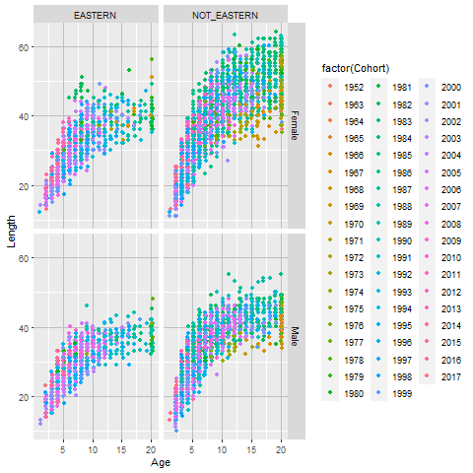s

Figure 1. Jittered raw age-length data for female GOA rex sole by area (the Eastern GOA and Western-Central GOA) and by cohort.
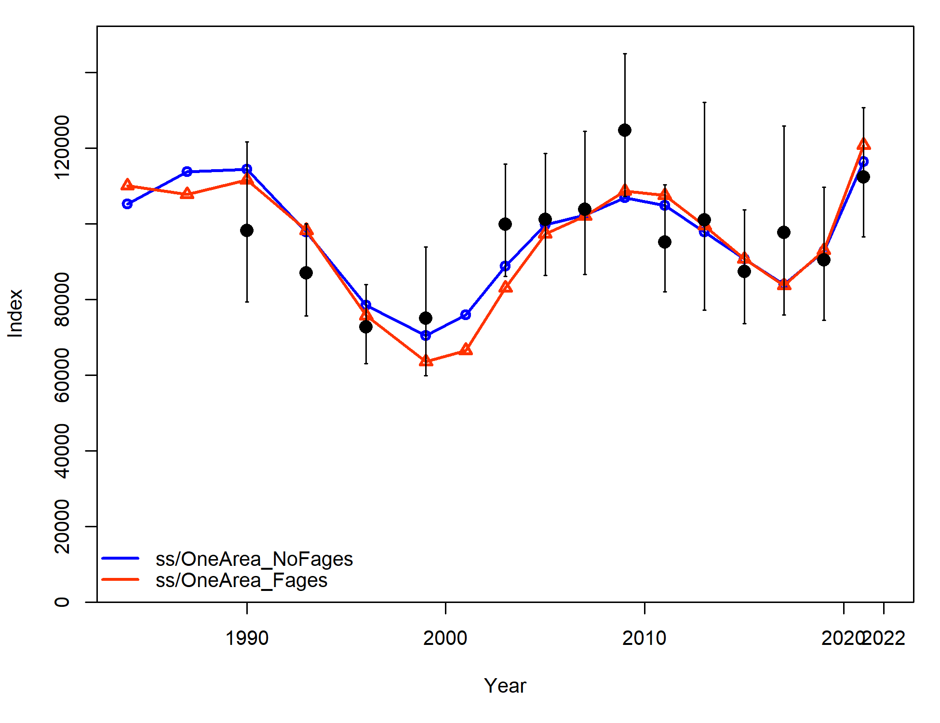

Figure 2. Fits (lines) to the GOA bottom trawl survey biomass index over time from the one area model without fishery ages included (blue) and with the fishery ages included (red). Observed GOA survey biomass is shown with black dots. Vertical lines show the asymptotic 90% confidence intervals for survey biomass observations.

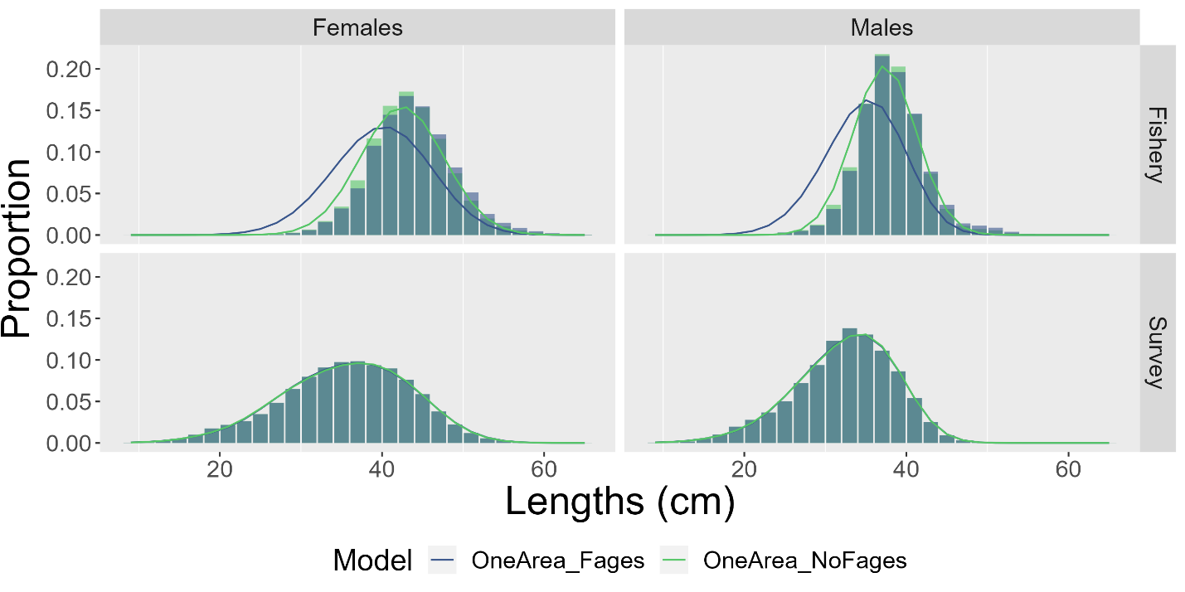

Figure 3. Fits (lines) to female and male length composition data aggregated by year (shaded regions) for the one area model without fishery ages included in model inputs (green) and with fishery ages included in model inputs (blue).
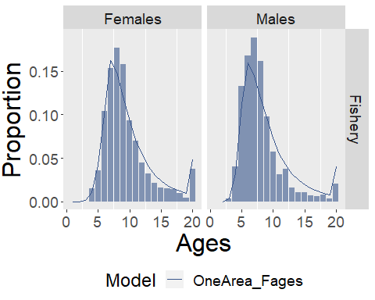

Figure 4. Fits (lines) to female and male fishery age composition data aggregated by year (shaded blue regions) for the one area model with fishery ages included in model inputs.
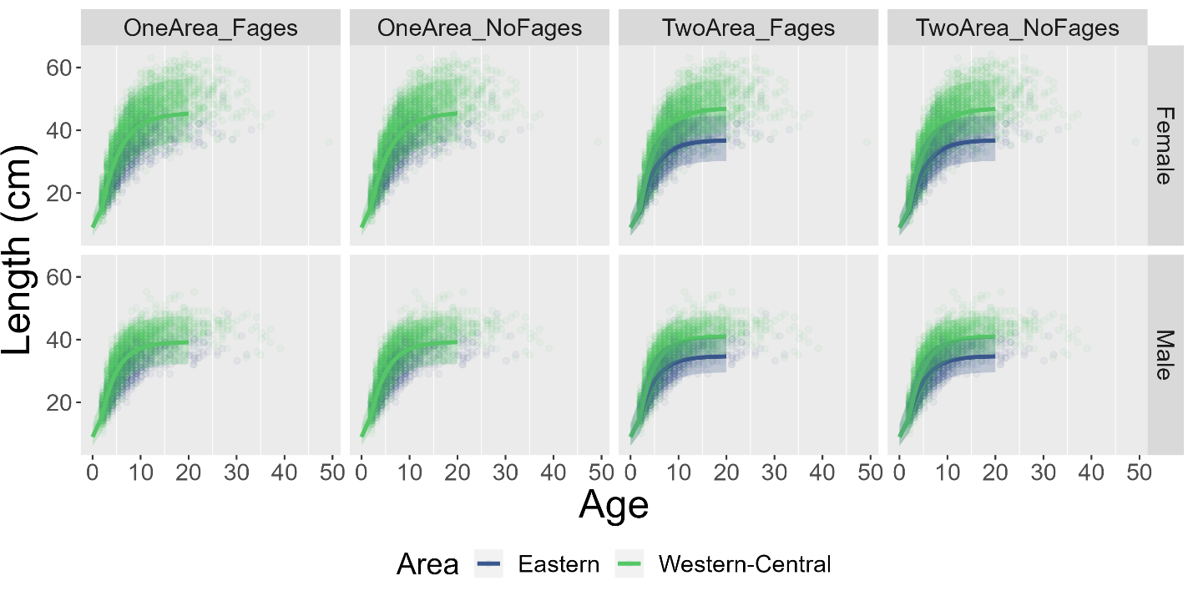

Figure 5. Raw bottom trawl survey data age-length data by area and sex, overlayed with mean von-Bertalanffy growth curve estimates for each model (columns) and 90% asymptotic uncertainty intervals around the means (shaded areas). The Eastern GOA is shown in green and the Western-Central GOA is shown in blue. For one-area models the green lines denote the mean von-Bertalanffy growth curve estimated within the model using data from all areas.
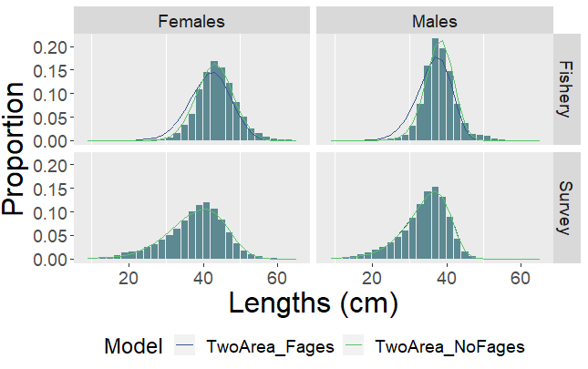

Figure 6. Fits (lines) to female and male fishery length composition data for the Western-Central GOA with data aggregated over year (shaded regions) for the two-area area model.
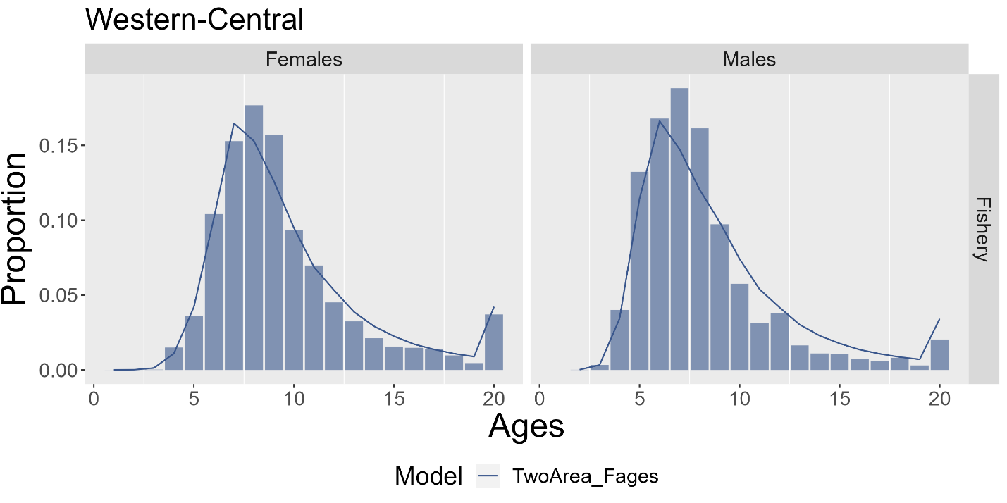

Figure 7. Fits (lines) to female and male fishery age composition with data aggregated by year (shaded regions) for the two-area area model with fishery ages included in model inputs.
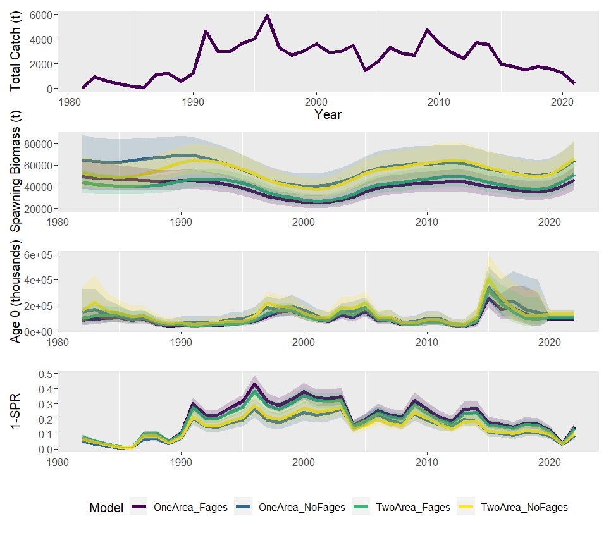

Figure 8. Time series of total catch (all catches occurred in the Western-Central GOA), as well as model-specific spawning biomass, age 0 recruitment, and fishing intensity (measured as one minus the spawning potential ratio). The one area model with fishery ages is shown in purple, the one area model without fishery ages is in blue, the two area model with fishery ages is shown in green, and the two area model without fishery ages is shown in yellow.
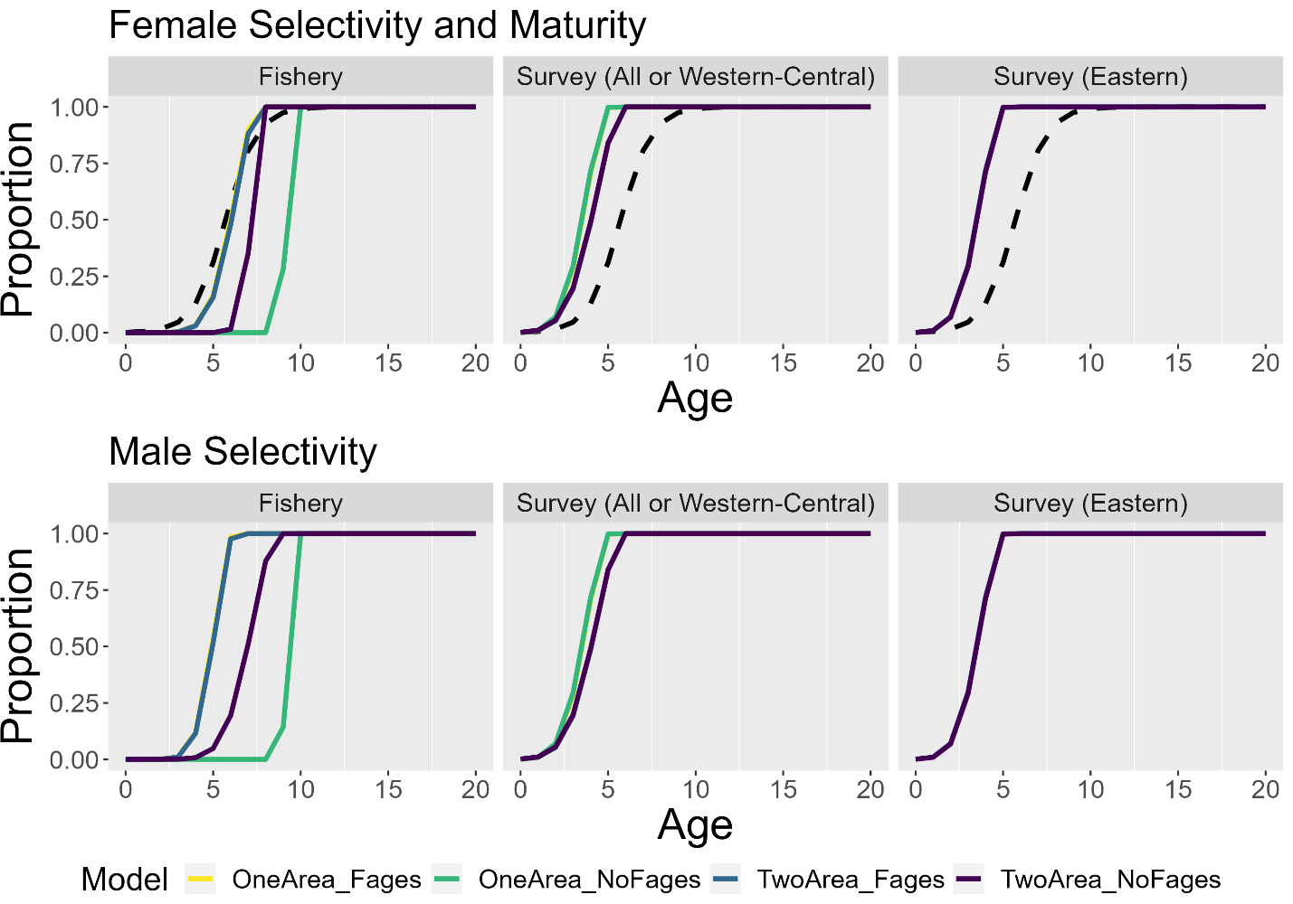

Figure 9. Fishery and survey selectivity-at-age for females (top row) and males (bottom row) for each of the four models. Female selectivity curves are overlaid on maturity-at-age (dashed black lines).

